How to create service IP, internal IP and ingress IP: -

- We login putty with our common credential.
- Check the pwd
- Move your internal.yml and ingress-controller-internal.yml from current location (Download) to /home/rrai3014@7-11.com with the help od win SCP. then only we can see the file in our current directory.
- Check with ls cmd your file is reflection or not

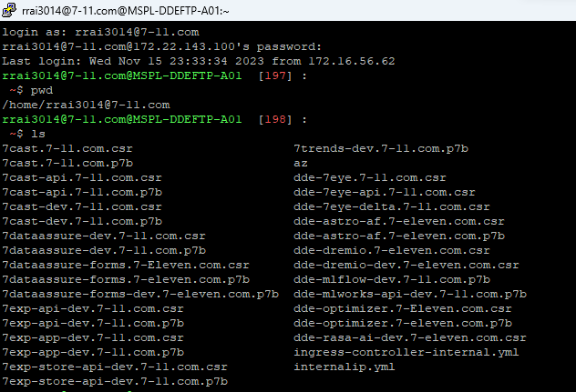

7-check with cat each file and if needed any change then with the help of vi you can edit the app name. don’t put any numeric or capital letter .
8-you have to open with vi and type in key board i to insert or edit. then type esc+shift+:wq to save.
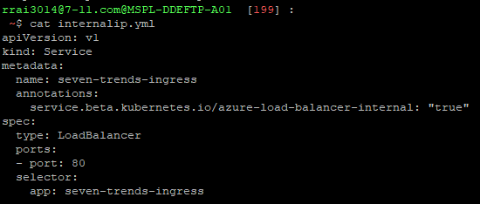
9-same as do for ingress too
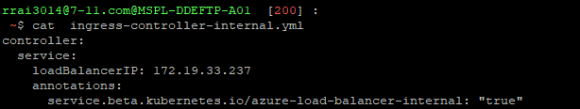

10-now all set with both files then we have to login relevant cluster (ex- aksd-apic-002) to create new service IP
az account set --subscription "Enterprise Dev/Test Subscription" && az aks get-credentials --resource-group RG-Dev-APIC --name aksd-apic-002
11-confirm the cluster with cmd kubectl config current-context

12- with the help of cmd kubectl get svc check the current services
13- with the help of cmd kubectl get svc | grep tren (service name)

14-now we can run the command to create service IP
- First Create Private IP (Using the below file) internal-IP.yml
- kubectl create -f internalip.yml
- Then allocate this ip to as a service ip to trends app
15- we can proceed for ingress Ip
a)for ingress again we need to create one internal ip
b). install helm
c). First Create Private IP (Using the internal-IP.yml file)
d) Update the private ip in internal-ingress yaml

helm repo add ingress-nginx https://kubernetes.github.io/ingress-nginx

- Ingress Command : helm install exp-store-orch-controller ingress-nginx/ingress-nginx --namespace kube-system -f ingress-controller-internal.yml --set controller.replicaCount=1 --set controller.ingressClassResource.name=exp-store-orch-api
16-check the ingress with command
kubectl --namespace kube-system get services -o wide -w cycle-count-api-ingress-nginx-controller
or
kubectl get svc -n kube-system

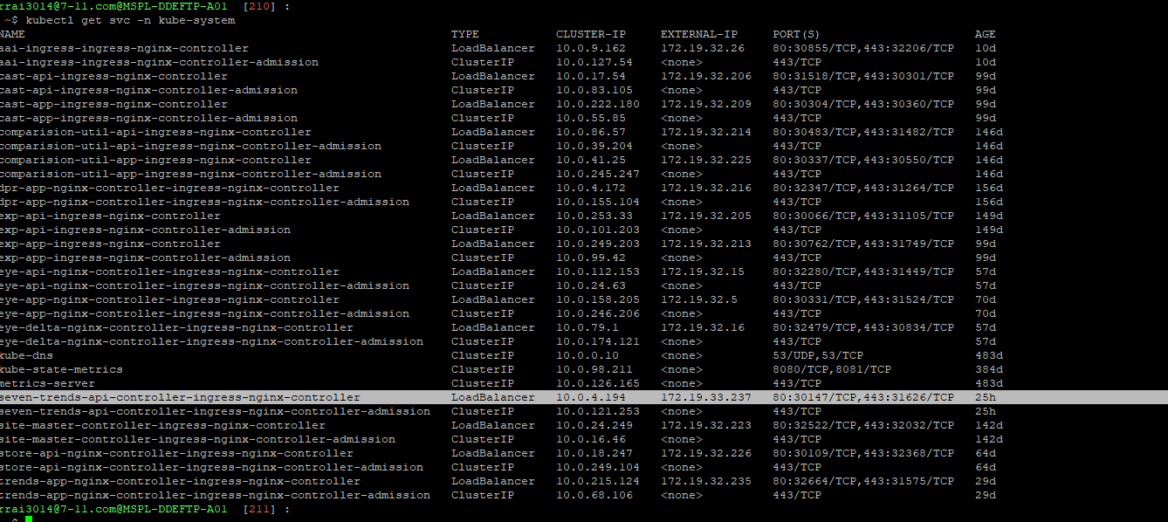

17- first it will show in pending state because the ingress in allocated with service ip
So its working as a service ip till now . after that we need to delete the service ip to work as a ingress because at a time it can work for one thing .
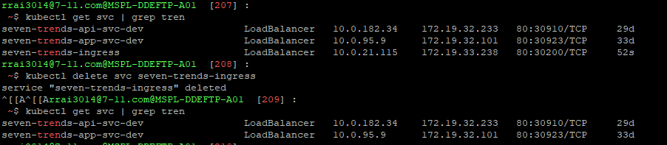
18-after deleting internal ip or service ip it will take 5 min to update ingress then it would be assign and it will not show as a pending state.
19- then we have to send DNS allocation request to take that ip and app name from snow portle.
Ex:- Please create a DNS record for the Internal Application.
Name :7trends-api-dev.7-11.com
IP Address: 172.19.33.237
Ref ticket:- INC9942224

20 – after allocation we can request for SSL cert and tls host name then we can modify the yml file too refer as 7cast app . after that we can run the pipeline.

